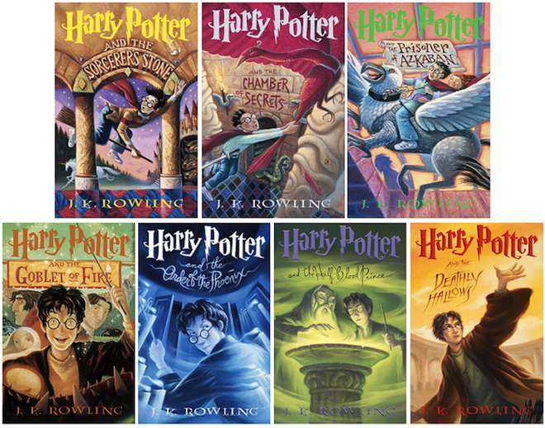

Welcome to
4th Grade!

August 16, 2018

Dear Parents/Guardians,
My name is Mr. Daniel Johnson, and I want to say how excited I am to have your child in my classroom! This year, your child will learn many important things, including much of Wyoming’s history, Next Generation Science investigations, and higher-level thinking skills in reading and math.
Your child’s only homework will be a required 30 minutes of reading daily. Since this is all, please ensure that it happens.
Your child will be given a planner that he or she will fill out daily so you know what your child’s assignments are. Each night please sign the binder for your child to bring to school the next day.
I am very excited to be a part of your child’s education! Once again, thank you for your support. If you have any questions or concerns either now or during the school year, please feel welcome to contact me through email or through the school phone number any time after 3:35pm. In addition, you can write on your child’s planner, and I will respond.
Communication between home and school is a key ingredient to your child’s success. Please take the time to read through the policies and procedures handbook that has been sent home with your child. If you have any comments, questions, or concerns please feel free to contact me by phone or email. Once you have read through the handbook, please fill out the form below and send it back to school with your child by Tuesday, August 21st.

Thank you,
Mr. Johnson
(307) 352-3225; johnsond@sw1.k12.wy.us

I have read through the policies and procedures handbook with my child

_________________________________ .
(child’s name)

We agree to work together with Mr. Johnson to make this a successful school year for everyone.

Parent signature: _____________________________________

Date: __________________________

Mr. Johnson’s
Policies and Procedures
Attendance
Parents and busses may begin dropping students off at 7:55. School begins at 8:15. Students who arrive after this time will be marked tardy.

Birthdays
Our children love to celebrate their birthdays! On your child’s birthday, you may choose to send in treats for the class. If you wish to provide a treat, we will serve them towards the end of the day. If you do not want to send treats or celebrate your child’s birthday, please let me know. All summer birthdays will be celebrated in May.

Electronics
If you want your child to have a cell phone, we cannot be responsible for it being lost, stolen or damaged. You will need to fill out a permission form and the office must approve it. It should be turned off or on silent and kept in a safe place like in the child’s backpack. No teacher should ever “see or hear” the phone in the classroom. If we do, it will be confiscated.

Homework
Your child will be required to read 30 minutes five nights a week and do a couple minutes of times tables review. Please sign your child’s homework planner to let me know this is getting done at home. Students whose planners have been signed regularly earn a free personal pan pizza from Pizza Hut at the end of the month.

Medicine
If a child needs to take any medication during the school day, a form must be on file at the office. The medicine should be brought in by an adult and given to the school secretary. Students are not allowed to transport medicine by themselves. THIS INCLUDES COUGH DROPS!

Media
For class rewards, we have watched rated G and PG movies right before Christmas and the end of the school year. We will make sure to let you know beforehand what movie we are watching in case you want your child to avoid certain films.
Transportation
For safety reasons, if your child will be going home a different way than what we have in our files, you MUST call the school or send a note. We will not let your child go with another adult or a different way unless we have been notified beforehand.

Water Bottles and Snacks
Your child may bring a spill-proof water bottle to school, filled only with WATER. Your child may bring a healthy snack to eat partway through the morning.

Behavior and Responsibility Expectations
Currently our school employs the “PBIS” system. Under this model our class works towards different rewards throughout the school year. Students may earn acorn tickets individually or for their class when they demonstrate appropriate behaviors in the hall, in the bathrooms, on the playground, and in classes. Student will be rewarded with different prizes at the end of each quarter.

Students have the opportunity to earn class rewards. As a class, students will work towards earning class points. When they reach the goal, the class will be rewarded with a prize.

I also have an individual student behavior plan as well. When the students are showing positive behaviors they move their clip up a behavior chart and receive points. When they are showing negative behaviors they move down the chart and lose points. Desired behaviors will earn students free time on Fridays to play games and have fun. Consistent inappropriate behaviors will reduce the amount of free time a student gets.

Behavior Graph
As previously mentioned, each month a new behavior graph will be inserted into your child’s binder. At the end of each day, they will graph their points. Please make sure the calendar stays in the binder for the entire month. The following diagram shows what each color on the behavior graph represents:
If the student moves his/her clip up to white, he/she will get to put gems in our class jar and earn extra acorn tickets.

Students move their clip up when the teacher catches them following expectations. They get to put gems in the jar.

The students start out each day on the “Ready to Learn”. They move their clip up or down depending on their choices each day.

If students receive a warning, they will move their clip down to orange.

If students continue to make poor choices, they will move to red. The teacher will choose to take away recess time or have them practice a skill or write an apology, etc.

If the student continues to make poor decisions, they move to black. This could mean a parent contact or reteach or even a discipline referral.

White
Excellent!
Green
Great Job
Purple
Good Job
Blue
Ready to Learn
Orange
Slow Down!
Red
Teacher’s Choice

Black
Teacher’s Choice or Parent Contac

